LABORATORY REPORT
Laboratory Activity 3: JavaScript Fundamentals 1
Loida B. Alagbate Applications Development and Emerging Technologies
Problem Sets
Problem 1: Grade Calculator
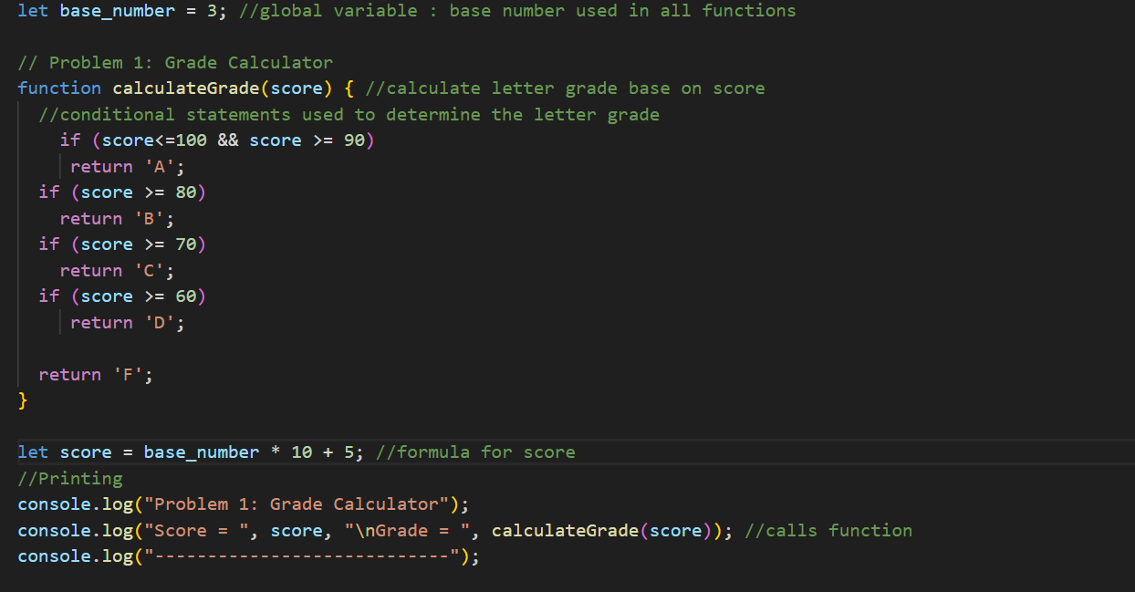
Description:
This program calculates the letter grade for a given score.
Variables:
- base_number – a global variable set to 3 (last digit of my student ID)
- score – its value will be based on base_number
Steps I did:
- Declared a global variable base_number and set it to 3.
- Created a function calculateGrade(score) to determine the letter grade based on score.
- Used if and else conditional statements to assign the correct letter grade according to the grading rules provided in the pdf.
- Declared a variable score outside the function and calculated it using the formula: score = base_number × 10 + 5.
- Printed the score and its corresponding letter grade.
OUTPUT
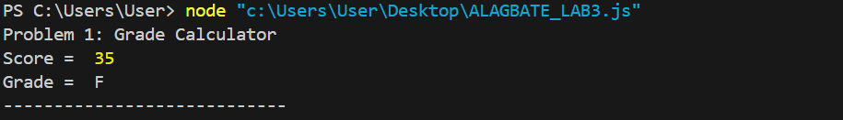
Problem 2: Star Pattern
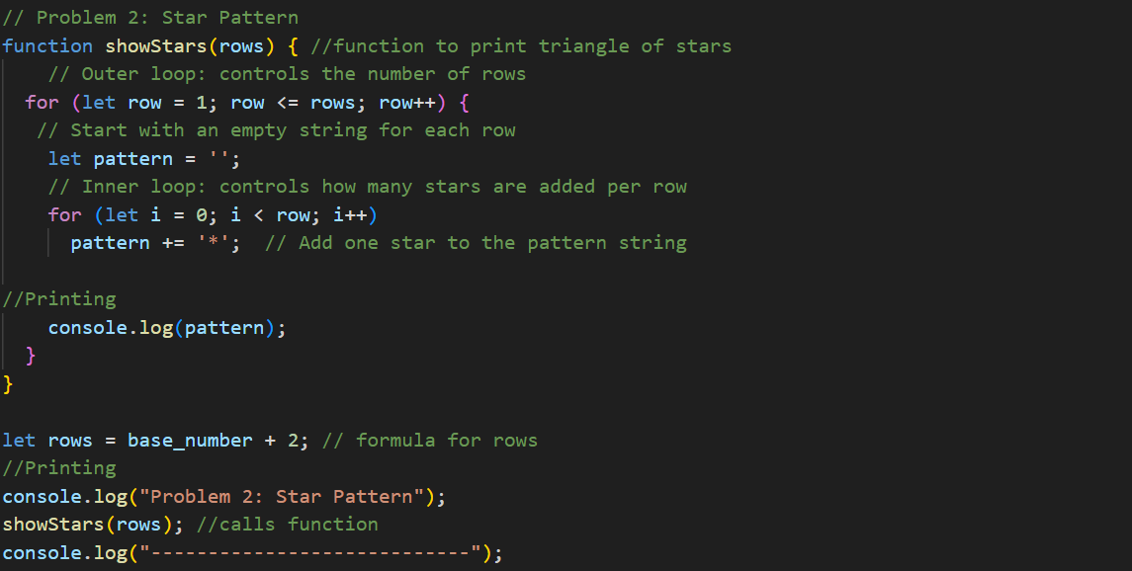
Description:
This program uses loops to print a triangle of stars.
Variables:
- base_number – global variable set to 3 that will later on be used to set the value of the number of rows.
- rows – number of rows in the triangle of stars (its value will be based on base_number)
- row – loop counter for the outer loop controlling rows
- i – loop counter for the inner loop controlling stars per row
- pattern –stores the stars for the current row before printing
Steps I did:
- Declared a function showStars(rows) to print the triangle of stars.
- Used a nested loop: the outer loop controls the number of rows, and the inner loop adds the correct number of stars per row.
- Calculated the number of rows using rows = base_number + 2.
- Called the function to print the triangle of stars to the console.
OUTPUT
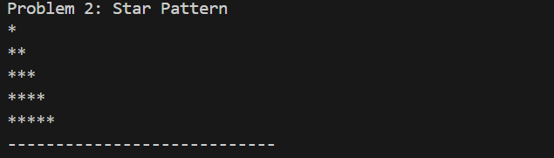
Problem 3: Prime Number Checker
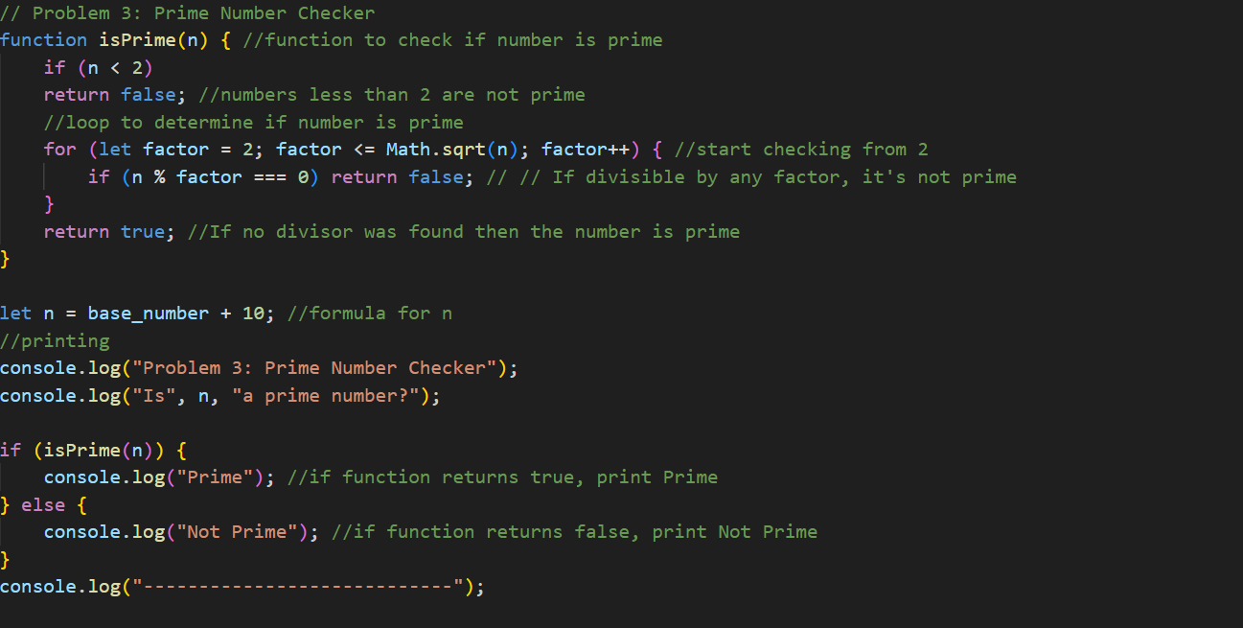
Description:
This program checks whether a number is prime.
Variables:
- base_number – used to calculate n
- n – number to check (its value will be based on base_number)
- factor – loop counter used to test divisibility
Steps I did:
- Declared a function isPrime(n) that determines if a number is prime.
- Checked if n is less than 2 and returned false if it is.
- Used a loop to test divisibility from 2 up to the square root of n; if any factor divides n, returned false.
- If no divisors were found, returned true.
- Calculated n using n = base_number + 10.
- Printed whether n is prime using an if-else statement to display "Prime" or "Not Prime" in the console.
OUTPUT
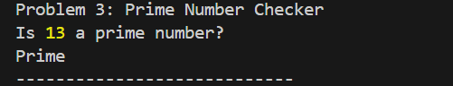
Problem 4: Multiplication Table
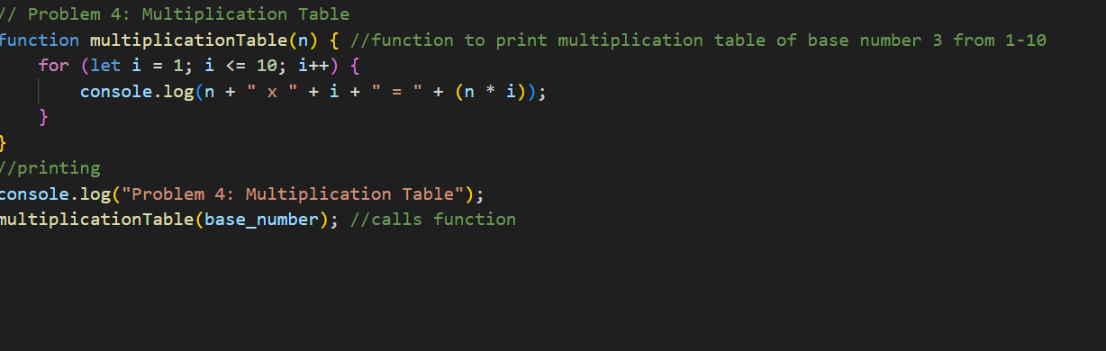
Description:
This program prints the multiplication table of n from 1 to 10.
Variables:
- base_number – global variable set to 3
- n – equal to base_number
- i – loop counter used to calculate products from 1 to 10
Steps I did:
- Declared a function multiplicationTable(n) to print the multiplication table.
- Used a loop from 1 to 10 to calculate and print each product (n x i).
- Called the function with base_number to print its multiplication table to the console.
OUTPUT
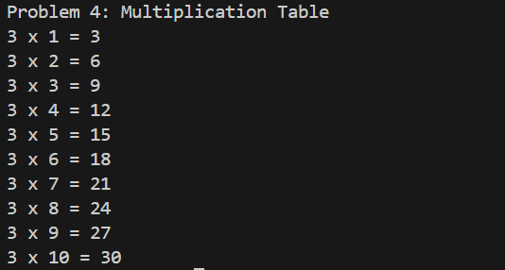

Github repository: LoidaAlagbate/ALAGBATE-APPDEV-LAB3

